./

GENESIS – Applied SDLC and Mini-project Summary Report



|  |  |  |  |  |  |
| --- | --- | --- | --- | --- | --- |
| **Ver. Rel. No.** | **Release Date** | **Prepared. By** | **Reviewed By** | **To be Approved** | **Remarks/Revision Details** |
| 1 | 07-12-20 | Sriram R M |  |  |  |
| 1 | 07-12-20 | Samudrala Apurva |  |  |  |
| 1 | 07-12-20 | Deepak Kumar Sahoo |  |  |  |
|  |  |  |  |  |  |
|  |  |  |  |  |  |

**Details**

Contents

Contents 4

Requirement: 5

State of the art: 5

4W1H: 5

SWOT Analysis: 6

Requirement analysis: 6

Testing: 7

Test Plan: 7

Design 9

High level design: 9

Low Level Design: 11

CI/CD: 13

Github Repository and Badges: 13

Github Repository Link: 13

# 

# Requirement:

## State of the art:

|  |  |  |
| --- | --- | --- |
|  | Existing Calculator | Scientific Calculator |
| Medical Application | No functions are present that can be used in medical field | Functions like BMI calculator, BP monitor and blood sugar monitor are present |
| Conversion Application | No unit conversion functions are present | Unit conversion functions like pound to kg, mile to km are present |
| Cost Analysis | Provides lesser functions | Provides numerous functions at the same rate |

## 4W1H:

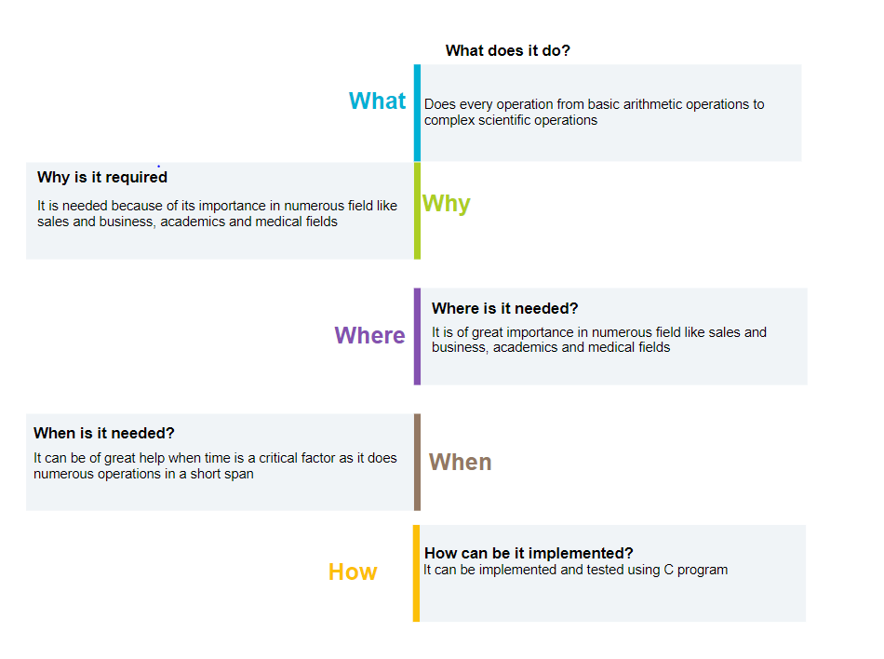

## SWOT Analysis:

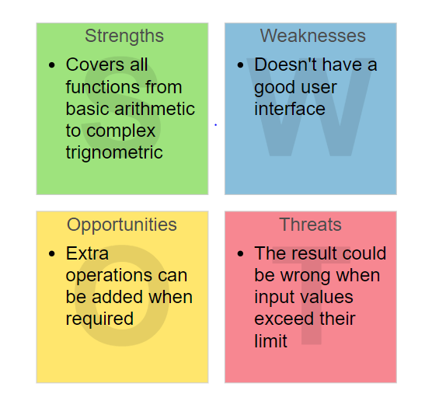

## Requirement analysis:

|  |  |  |
| --- | --- | --- |
| Requirement ID | High Level Requirement | Low Level Requirement |
| HLR_1 | Arithmetic functions | Addition, Subtraction, Multiplication, Division, Modulo-division, Factorial, IsPrime, IsEvenOdd, Square, Cube, Power |
| HLR_2 | Scientific functions | Sin, Cos, Tan, Sinh, Cosh, Tanh, Right Shift, Left Shift, Bit_and, Bit_or, Bit_exor, Bit_complement, Pythogoras |
| HLR_3 | Medical functions | BMI calculator, Blood sugar monitor, Blood pressure monitor, BPM monitor, Age calculator |
| HLR_4 | Conversion functions | Pound to Kg, Mile to km, Celsius to Fahrenheit, Inch to cm |

# Testing:

## Test Plan:

|  |  |  |  |  |  |
| --- | --- | --- | --- | --- | --- |
| **ID** | **Description** | **Expected input** | **Expected output** | **Actual output** | **Result** |
| T1 | Addition | add(10,23) | 33 | 33 | Passed |
| T2 | Subtraction | subtract(11,1) | 10 | 10 | Passed |
| T3 | Multiplication | multiply(2,5) | 10 | 10 | Passed |
| T4 | Division | divide(10,2) | 5 | 5 | Passed |
| T5 | Percentage | perc(19,100) | 19 | 19 | Passed |
| T6 | Modulo Division | modulodivision(4,2) | 0 | 0 | Passed |
| T8 | Even/Odd | evenodd(4) | 1 | 1 | Passed |
| T7 | Prime | isprime(2) | 1 | 1 | Passed |
| T9 | Factorial | factorial(5) | 120 | 120 | Passed |
| T10 | Square Root | sq(4) | 2 | 2 | Passed |
| T11 | Cube Root | cu(8) | 2 | 2 | Passed |
| T12 | Power | power(2,4) | 16 | 16 | Passed |
| T13 | Sine | sin(90) | 1 | 1 | Passed |
| T14 | Cosine | cosine(90) | 0 | 0 | Passed |
| T15 | Tangent | tangent(45) | 1 | 1 | Passed |
| T16 | Hyperbolic Sine | sineh(1) | 1.175201 | 1.175201 | Passed |
| T17 | Hyperbolic Cosine | cosineh(1) | 1.543080 | 1.543080 | Passed |
| T18 | Hyperbolic Tangent | tangenth(1) | 0.761594 | 0.761594 | Passed |
| T19 | Right Shift | right_shift(10,2) | 2 | 2 | Passed |
| T20 | Left Shift | left_shift(10,2) | 40 | 40 | Passed |
| T21 | Bitwise AND | bit_and(6,3) | 2 | 2 | Passed |
| T22 | Bitwise OR | bit_or(10,10) | 10 | 10 | Passed |
| T23 | Bitwise XOR | bit_xor() | 2,2 | 0 | Passed |
| T24 | Bitwise Complement | bit_complement(9) | -10 | -10 | Passed |
| T25_01 | BMI | BMI(75,1.78) | 23 | 23 | Passed |
| T25_02 | Age Calculator | age_calculator(7,12,2020,26,11,1998) | 22 | 22 | Passed |
| T25_03 | Blood Pressure | blood_pressure(100) | 1 | 1 | Passed |
| T25_04 | Blood Sugar | blood_sugar(145) | 0 | 0 | Passed |
| T25_05 | BPM | BPM(72) | 1 | 1 | Passed |
| T25_06 | Pythagoras | pythogoras(4,3) | 5 | 5 | Passed |
| T25_07 | Pound to kilogram | pound_to_kg(163) | 73 | 73 | Passed |
| T25_08 | Mile to kilometre | mile_to_km(7) | 11 | 11 | Passed |
| T25_09 | Celsius to Fahrenheit | celcius_to_fahrenheit(28) | 82 | 82 | Passed |
| T25_10 | Inch to Cm | inch_to_cm() | 23 | 58 | Passed |

# Design

## High level design:

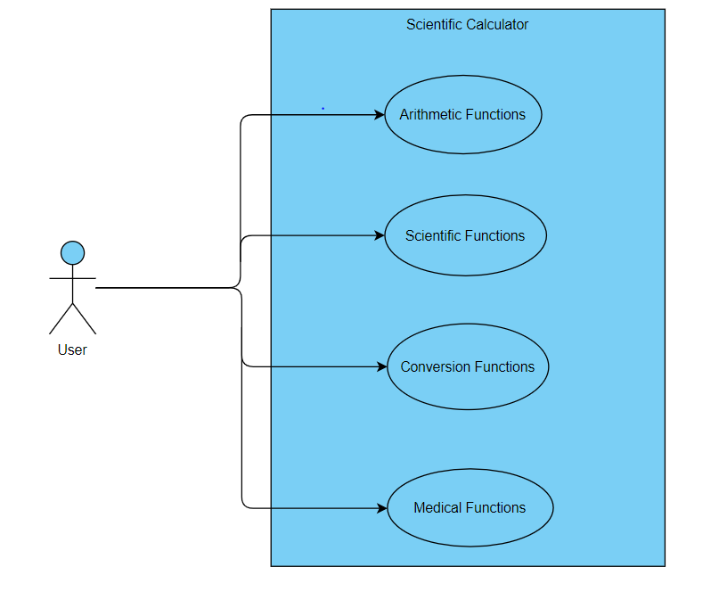

Fig : Behavioural - Use case diagram

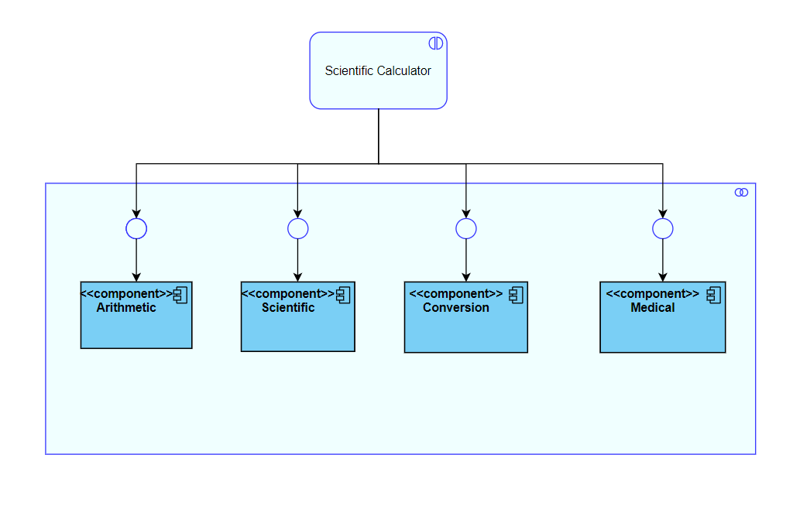

Fig :Structural - Component diagram

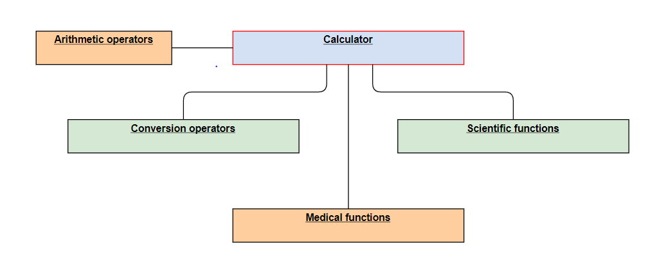

Fig : Structural - Deployment diagram

## Low Level Design:

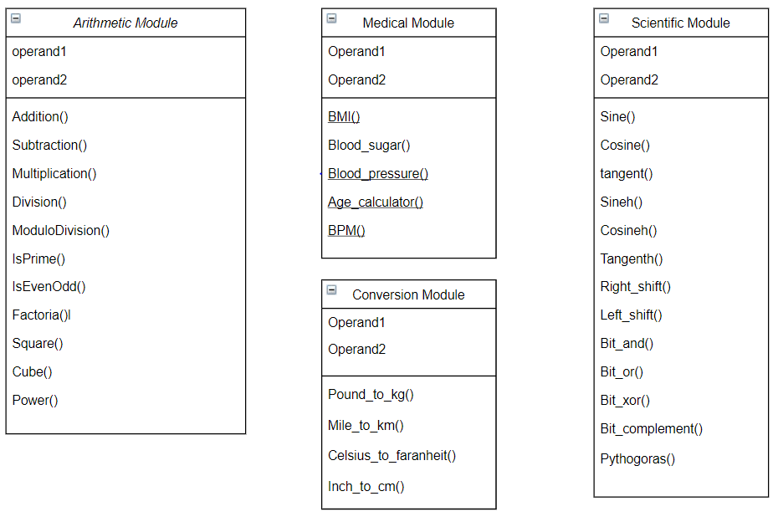

Fig : Structural - Class diagram

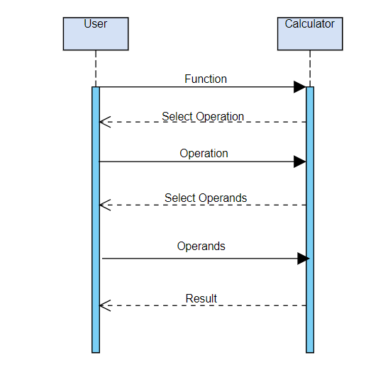

Fig : Behavioural - Sequence diagram

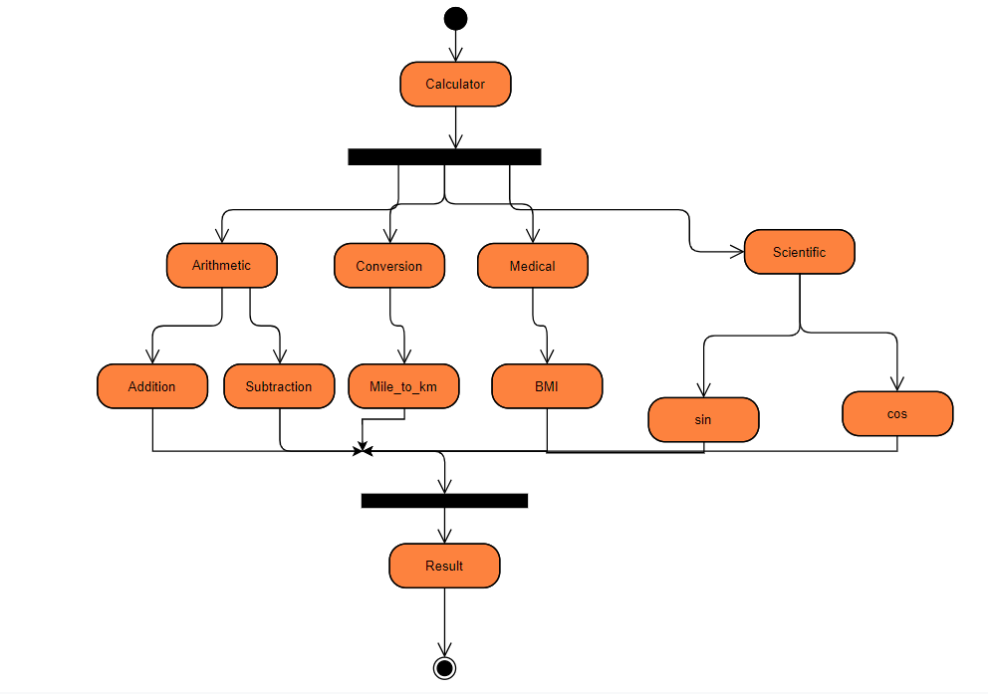

Fig : Behavioural - Activity diagram

# CI/CD:

## Github Repository and Badges:

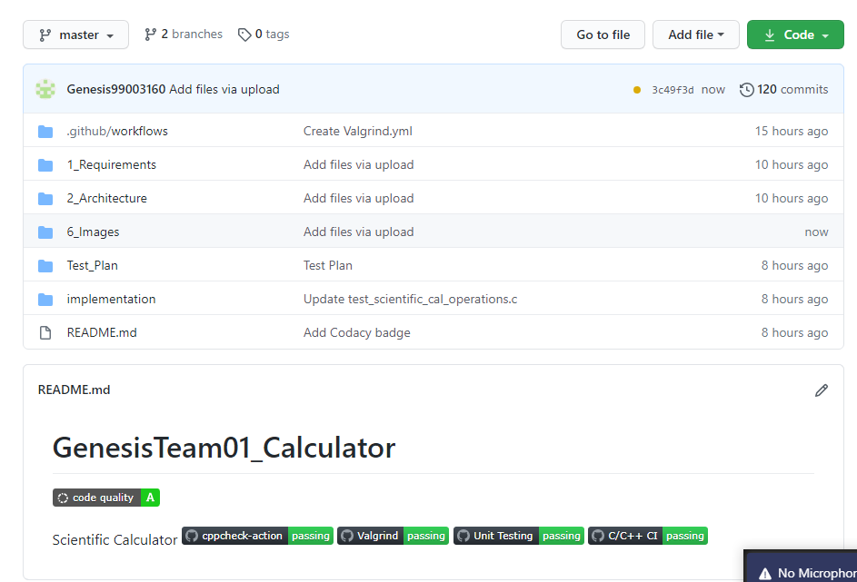

## Github Repository Link:

<https://github.com/99003161/GenesisTeam01_Calculator>